**SDD Prelim Task 3**

**Task 1: Selection**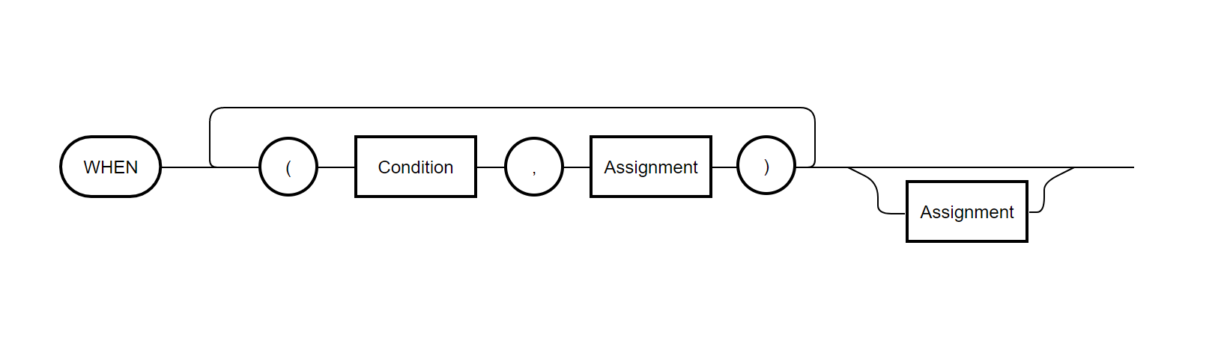  
**Task 2: Input Output Statements**

Statement

Statement

Start Input A !  
 Input B !  
 When (A < B, Set C to A + B) Set C to A – B !  
 Output C   
Stop

**Task 3:**

Start  
 Input J1 !  
 Input J2 !  
 When (J1 = J2, Set A3 to 0) (J1 < J2, Set A3 to -1) Set A3 to 1 !  
 Output A3   
Stop

**Task 4:**

**Input =** Input <Identifier>  
**Output =** Output <Identifier>  
**When =** When (<Condition>,<Statement>){(<Condition>,<Statement>)}[<Statement>]

**Task 5:**

Start  
 Set A to 1 !  
 Do   
 Output A !  
 Set A to A + 1 !   
 Awaiting A = 21

Stop

**Task 6:**

